Room Mate Design Proposal

Dan Westenberger

**Overview**

Room Mate will be an app targeted at young adults between 18-30 who share a household. It is an alternative to the classic apartment whiteboard that is so often used to coordinate grocery lists, chores and notes. The app will essentially be a tiny closed social network that you share exclusively with your fellow roommates. The app will feature a shared grocery list, calendar and chores list. It will have many features that will make the process of organizing your household much less effort, much more streamlined, and there will be far less conflict as a consequence.

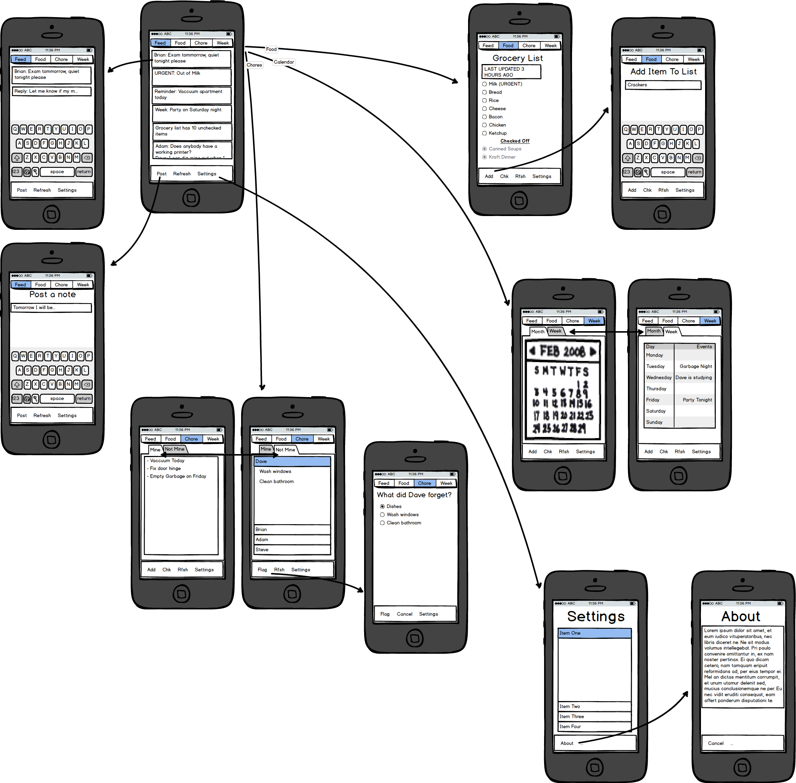

**Feed Page**

The feed page will be the main landing point for the app. It will be the page that users will spend the majority of their time on. The feed page will be a chronological list of various reminders, notes and notifications. You will be able to post a note from this page, and other roommates will be able to reply to your notes. These notes will function very much like Facebook status updates but will be primarily geared towards household-specific things. The updates will come through in narrow card form, and the cards will be color coded to match which type of update they are (note, groceries, events, chores). From here you will be easily able to switch to any of the other pages of the app.

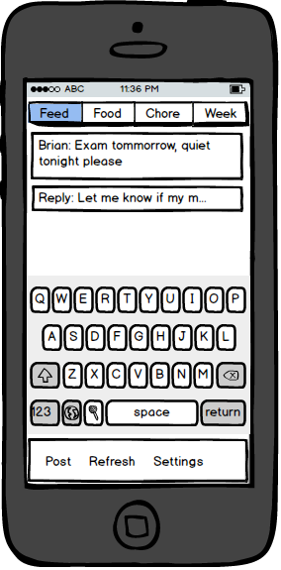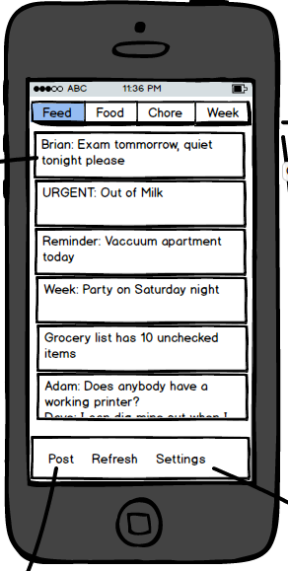

**Grocery List**

This will be a grocery list that is synchronized between all members of the household. One important element to this list is that it will feature a persistent text field that will always show how long ago the list was last updated. This will encourage users to keep their lists up-to-date. If they are unable to, they may want to check with their roommates before going grocery shopping if the list hasn’t been updated in a day or so.

When an item is checked off the list, it will drop into the ‘checked off’ section so that users can see the history in case they mistakenly checked something off. Additionally, items can be flagged as urgent, which will populate an urgent message in the feed so that all roommates will see, for example, that they are out of milk. Time permitting, I will also attempt to implement push notifications to immediately alert all roommates when an urgent notification comes up.

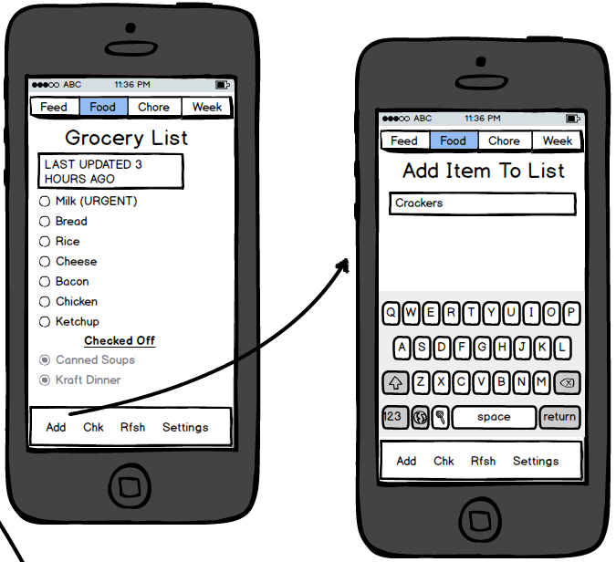

**Calendar**

The goal for this calendar is to be extremely simplistic. This is not intended to be a replacement for a user’s electronic calendar. Rather, this should be a simple way for users to quickly schedule events that other roommates would want to know about. For example if a party is happening at the apartment, if a user needs peace and quiet to study for an exam, if the plumber is coming on a certain day, etc. Events will populate in the feed when they are a few days away. The calendar page will have a week view and a month view. Time permitting I will try to include support for recurring events.

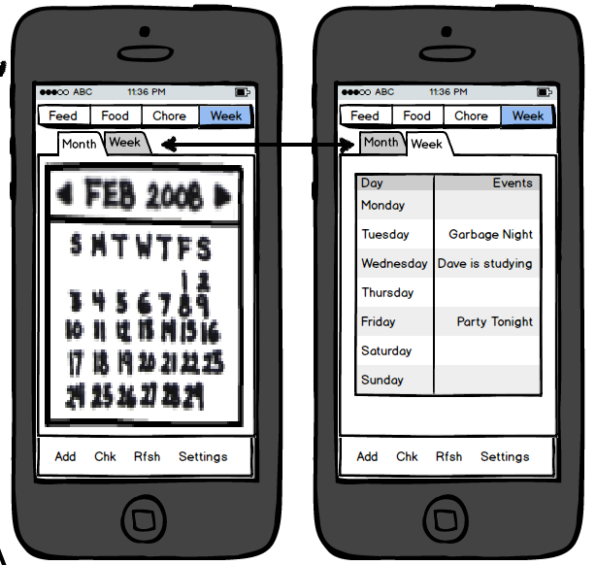

**Chores**

This page will be the place that people are assigned chores. The reason I’m not bundling this into the calendar is because I feel that chores between roommates are often fairly loosely structured. A user might postpone a chore by a day or two and it would be nice to not have to constantly update the calendar when this happens.

This page will have two sections. “Mine” will show chores that apply to the current user. The user will input their own chores, and can add/remove them from this page. The second section “Not Mine” will show an accordion menu with each roommate’s name as headings, and each user will have a list of chores below their name. There will also be a flag function. This is how users flag other roommates for not completing chores. For example if Dave forgets to clean up his dishes, a user can flag him for not doing dishes. The app will then push a friendly reminder to Dave’s phone that he forgot to clean his dishes. The purpose of this is to eliminate passive-aggressive notes and arguments from coming up.

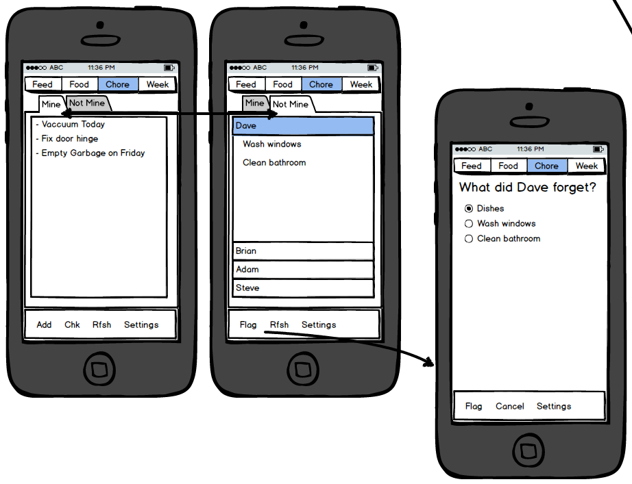

**Settings**

The settings page will have fairly obvious contents which I will implement as they come up. One thing that this page will need to have is the ability to add/remove roommates from the household. This page will have a link to the About page.

**About**

This page will display information about myself and the app.

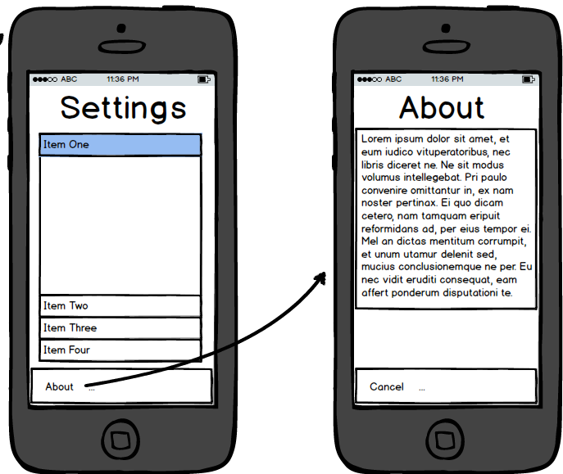

**The Guts**

The biggest challenge with this app will be creating and maintaining a MySQL database to keep track of all of the data. We have experience with PHP and MySQL so this should not be insurmountable. Ideally the app will work such that many users from different phones can post updates and refresh their pages and see updates come through in the proper order without missing any notifications. The rest of the app will be simple front-end UI stuff. Another challenge that I may face if the rest of the app comes together quickly enough is setting up push notifications. If I can have the app push an alert to the phone when the app is not open, that would be very useful functionality.